A398-Asia-China-Liangzhu-Three Prong Crown Ornament-Jade–Mid Liangzhu-3400-2800 BCE

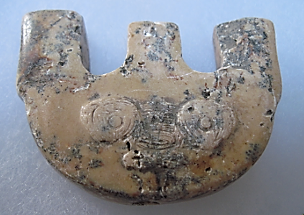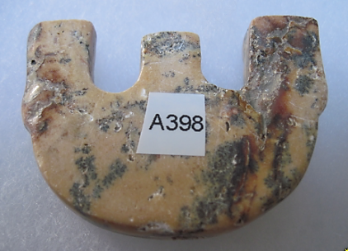

Figs. 1-2. China-Liangzhu-Three Prong Crown Ornament-Jade–Mid Liangzhu-3400-2800 BCE

Case no.: 5

Accession Number: A398

Formal Label: China-Liangzhu-Three Prong Crown Ornament-Jade–Mid Liangzhu-3400-2800 BCE

Display Description:

The Liangzhu Culture Three Prong Crown Ornament is generally a flat thick jade body with one perforation in the central spoke that continues through to the bottom. Jade Three Prong Crown Ornament rectos have a bas-relief that is suggestive of the so-called “taotie” mask. The taotie is a bi-laterally symmetrical animal mask that is placed in the central area of the recto. This iconography undoubtedly harkens back to a pre-Neolithic period when shamanic imagery was the symbolism of hunter-gatherers and was the animal imagery that was inscribed on petroglyph panels.

The weathering on this one may be due to the penetration of hematic fluids of the deceased.

**LC Classification:** NK5750.2.A1

**Date or Time Horizon:** Mid-Liangzhu Period-3000-2600 BCE

**Geographical Area:** Liangzhu culture, lower Yangtze River delta

Maps:



Fig. 4. China, Neolithic Period, ca. 8000 - ca. 2000 BCE after https://etcweb.princeton.edu/asianart/assets/map_china_neolithic.gif

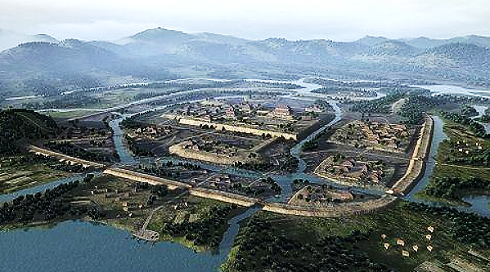

**Fig. 5. Liangzhu (300 ha)** showing the packed earthen perimeter wall, canals, residences and the central rectangular Mojiaoshan 莫 角 山 ritual center after an artist’s conceptualization **after** <http://p3.pstatp.com/large/615f00050b7a0d5bc064>.



Fig. 6. **Liangzhu (300 ha) model** showing the packed earthen perimeter wall, canals, residences and the central, rectangular Mojiaoshan 莫 角 山 3 ha, 10 m-high, ritual center. In addition, there were smaller, rammed-earthen platforms, some of which were constructed of fired adobe bricks. After an artist’s conceptualization **after** <http://p3.pstatp.com/large/616100014bf6036976ba>.

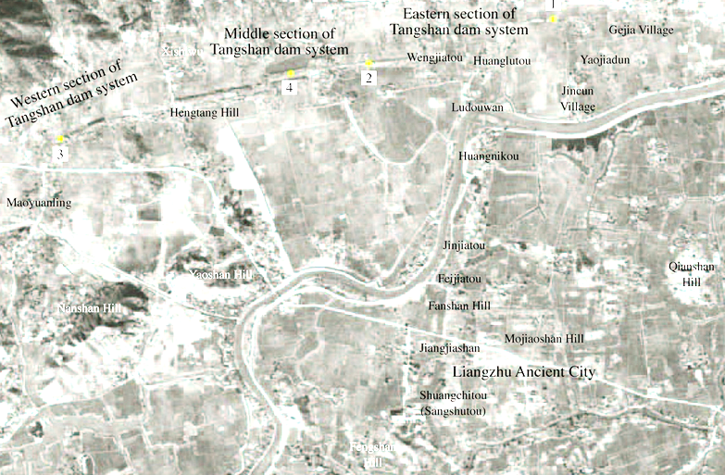

Fig. 7. Liangzhu complex with subsidiary sites and dams after https://www.degruyter.com/view/j/char.2016.16.issue-1/char-2016-0010/graphic/j_char-2016-0010_fig_002.jpg

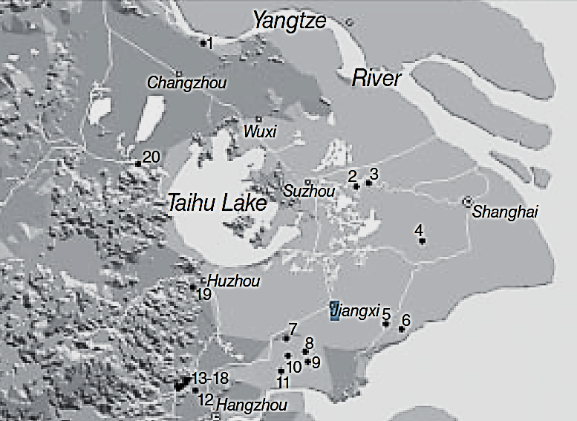

Fig. 8. Detail of major Middle Liangzhu associated sites. After Zhou Ying 2007.

1, Gaochengdun 高 城 墩; 2, Zhaolingshan 赵 陵 山; 3, Shaoqingshan 少 卿 山; 4, Guangfulin 广 富 林; 5, Pingqiudun 平 丘 墩; 6, Daimudun 戴 母 墩; 7, Xindili 新 地 里; 8, Pu’ anqiao 普 安 桥; 9, Zhangjiabang, 赵 家 浜, Xujiabang 徐 家 浜; 10, Heyedi 荷 叶 地; 11, Xubuqiao 徐 步 桥; 12, Miaoqian 庙 前; 13–18, Yaoshan 瑶 山, Fanshan 反 山, Huiguanshan 汇 观 山, Boyishan 钵 衣 山, Shangkoushan 上 口 山, Mojiaoshan 莫 角 山; 19, Yangjiabu 杨 家 埠; 20, Yannan 堰 南.

**GPS coordinates: ca** N 30°24', E 120°

**Cultural Affiliation**: Liangzhu culture, lower Yangtze River delta, 3300-2250 BCE

**Medium:** Jade

**Dimensions:** H 2.12 in, 53.79 mm; L 3.6 in, 91.34 mm

**Weight:**

**Condition:** original

**Provenance:** Yuhang County, Zhejiang Province

**Discussion:**

The bas-relief, engraved Taotie motif (a bi-laterally symmetrical animal mask) surmounted by a bas-relief, engraved shaman with a feather headdress, who has mastery, literally, over his animal spirit below. This iconography undoubtedly has its origins in the Paleolithic Period when shamanic imagery characterized the symbolism of hunter-gatherers who depended on wild boars and other animals for part of their sustenance (see Biot 1851).

Accordingly, animal taotie imagery was also pecked and inscribed as wild boar animal mask petroglyphs.

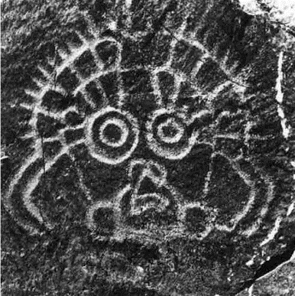

Fig. 9. Petroglyph of wild boar animal mask from Ningxia, China, after https://www.researchgate.net/figure/Face-like-motif-at-the-Helankou-site-Helan-Shan-Ningxia

By 3000-2600 BCE during the Mid-Liangzhu Phase, Liangzhu culture achieved a pinnacle of early cultural, engineering and economic development in a city with a size of about 300 ha that involved exquisite jade artistry, hydraulic planning and commerce. A suite of expertly designed and manufactured jade objects in élite burials provide a glimpse of the élite artisans who conceptualized and executed mythological, religious and ideological symbols into jade artifacts. This symbolism had evolved from a hunter-gatherer shamanic background into an animal husbandry of domesticated wild boars, that played an important economic and symbolic rôle in the development of Liangzhu culture. The ritual center of Mojiaoshan reflects a social cohesion that also enabled the organization of large-scale, collective, hydraulic engineering endeavors, including the construction of reservoirs, levees, dams, and canals that facilitated improved transportation and rice agriculture (Liu 2017).

Archaeological artifacts from the Mid-Liangzhu Phase (3000–2600 BCE) mostly came from the following sites (Fanshan, Gaochengdun 高 城 墩, Nanjing and Jiangyin 2009, Yaoshan, Zhaolingshan burial M77, Shaoqingshan 少 卿 山, Suzhou Museum 1988, and Guangfulin 广 富 林, Shanghai Archaeology 2008). However, the provenance of the current artifact is uncertain and so is given with the GPS coordinates of the original Liangzhu site.

DNA from Liangzhu culture sites around Taihu Lake exhibit high frequencies of Haplogroup O1 which was absent in other archaeological sites that were sampled inland of the Liangzhu Complex. Haplogroup O1 is common to modern Austronesians and Taiwanese Austronesians (TAN) (Li *et al*. 2007). O1 probably came from those Liangzhu Austronesians (LAN) who had been displaced from the mouth of the Yangtze River delta by an economic crash of the LAN ca 4500 BCE possibly induced by a meteor that struck at the present location of Taihu Lake, a meteoric crater (Erkang *et al*. 2002). Recent studies show that special micro-fractures in quartzite were formed during the unloading process after the compression at the peak of an impact event (Wang, Wan, Xu 2002). Bayesian phylogenetic analysis allows us to reconstruct a history of early Austronesians arriving in Taiwan in the north ~4,000 BCE, spreading rapidly to the south due to this catastrophic event (Ko *et al*. 2014). Those LAN culture sites that reformed round Taihu Lake took 800 years, from 4200 BCE until 3400 BCE, to recover at the Early LAN Period. Later, ca 2200 BCE at the Late LAN Period, a series extreme floods from diversions of the Yangtze River indicated by intrusions of mud and sand into the cultural layers of Late LAN Period sites mark this event and a second wave of LAN emigrating to Taiwan. Subsequently, one trajectory of TAN migrants began to sail east via the Buka Strait in the Solomon Islands, which became a staging area for the populating of Polynesia ca. 2000 BCE (Ko *et al*. 2014). Another trajectory of TAN migrants sailed north to Luzon in the Philppines (Hung 2005 a,b)

.

**References:**

Biot, Jean Baptiste. 1851. *Le Tcheou-li: ou, Rites des Tcheou.* Paris: Imprimerie nationale, 1851. 3v.

Chang, K.C., Xu, P. and Lu, L. 2005. *The formation of Chinese civilization: an archaeological perspective*. New Haven: Yale University Press.

Childs-Johnson, Elizabeth. 1988. *Ritual and Power: Jades of Ancient China*. New York: China House Gallery, China Institute in America.

Childs-Johnson, Elizabeth. 2009. “The Art of working Jade and the rise of civilization in China.” In Elizabeth Childs-Johnson, *Early Chinese jades in American Museums*. Beijing: The Science Press, China Science and Technology Publishing and Media Co., Ltd., 2009, pp. 291-393.

Erkang, Wang, Yuqiu Wan, Shijin Xu. 2002. “Discovery and implication of shock metamorphic unloading microfractures in Devonian bedrock of Taihu Lake,” *Science in China Series D: Earth Sciences*, 45 (5): 459–467.

Gu Fang. 2005. *Complete collection of unearthed jades in China*. 15 v. Beijing: China Science and Technology Publishing and Media Co., Ltd.

Hayashi, Minao. http://lms01.harvard.edu:80/exlibris/aleph/u20_1/alephe/www_f_eng/icon/f-separator.gif林巳奈夫. 1991. Chūgoku kogyoku no kenkyū. http://lms01.harvard.edu:80/exlibris/aleph/u20_1/alephe/www_f_eng/icon/f-separator.gif中國古玉の研究. Tōkyō: Yoshikawa Kōbunkan; 東京: 吉川弘文館, 1991.

Hayashi, Mineo. 林巳奈夫. 1990. “On the Chinese Neolithic jade Tsung/Cong,” *Artibus Asiae*, 50(1/2):5-22.

Hayashi, Mineo. 林巳奈夫.1973.  *Toyo Gakuho* [*Journal of the Research Dept. of the Toyo Bunko*] 45:1-57.

Hung, Hsiao-Chun. 2005a. The culture interaction between Taiwan and adjacent islands—the origins and dispersal of Austronesian-speaking peoples, in *The Archaeology of Southeast Coastal Islands of China Conference*: 249–269, ed. Jonas Chung-yu Chen and Jian-Guo Pan. Taiwan: Mazu County Government (in Chinese).

Hung, Hsiao-Chun. 2005b. Neolithic interaction between Taiwan and northern Luzon. Journal of *Austronesian Studies* 1(1): 108–133.

Ko, A.M.S., Chen, C.Y., Fu, Q., Delfin, F., Li, M., Chiu, H.L., Stoneking, M. and Ko, Y.C., 2014. “Early Austronesians: into and out of Taiwan,” *The American Journal of Human Genetics*, *94*(3): 426-436.

Laufer, Berthold. 1912. *Jade: a study in Chinese archaeology and religion.* Field Museum of Natural History, Publication 154, Anthropological series, vol. X. Chicago.

Li, Hui; Huang, Ying; Mustavich, Laura F.; Zhang, Fan; Tan, Jing-Ze; Wang, Ling; Qian, Ji; Gao, Meng-He; Jin, Li. 2007. "Y chromosomes of prehistoric people along the Yangtze River," *Human Genetics* 122: 383–388.

Liu, Bin, Ningyuan Wang, Minghui Chen, Xiaohong Wu (吴小红), Duowen Mo, Jianguo Liu, Shijin Xu, and Yiji Zhuang. 2017. Earliest hydraulic enterprise in China, 5,100 years ago. *Proc*

*Natl Acad Sci USA* 114:13637–13642.

Wenbao, Lu. 1998. “Cong-shaped bead.” In Liangzhu Culture Museum, ed., *The dawn of Chinese civilization: Jades of the Liangzhu culture.* Hong Kong: Liangzhu Culture Museum and The Art Museum, The Chinese University of Hong Kong.

Wu, Li. 2014. "Holocene environmental change and its impacts on human settlement in the Shanghai Area, East China," *Catena* 114: 78–89

Zhejiang [ 浙 江 省 文 物 考 古 研 究 所]. 2003. 瑶 山 (*Yaoshan Site*). Beijing: Wenwu.

Zhejiang [ 浙 江 省 文 物 考 古 研 究 所]. 2005a. 反 山 (*Fanshan Site*). Beijing: Wenwu.

Zhejiang [ 浙 江 省 文 物 考 古 研 究 所]. 2005b. 良 渚 遗 址 群 (*Liangzhu Site Group*). Beijing: Wenwu.

Zhejiang [ 浙 江 省 文 物 考 古 研 究 所]. 2008. 杭 州 市 余 杭 区 良 渚 古 城 遗 址 2006–2007 年 的 发 掘 (Excavation of the Liangzhu Ancient City Site 2006–2007 at Yuhang of Hangzhou). *Kaogu* 2008 (7): 3 – 10.

Zhang, Chia; Hsiao-Chun, Hung. 2008. "The Neolithic of Southern China–Origin, Development, and Dispersal," *Asian Perspectives*. 47:2, 309–310.

|  |
| --- |
| Zhou Ying. 2007. 东方文明的曙光: 良渚遗址与良渚文化 = Dong fang wen ming de shu guang: Liang zhu yi zhi yu liang zhu wen hua = *The Dawn of the Oriental Civilization: Liangzhu site and Liangzhu culture.* Beijing: China Intercontinental Press. |